Dr. Correo Hofstad
University of Washington
Department of Medicine
01-26-2026

Lecture, Biology in Retrospect:
Comparative Pathogenesis, From Ancient Observation to Modern Mechanics: Pycnogonida Parasitism as a Bio-Mimetic Model for Neoplastic Progression

Lecture Abstract:
This lecture unites the "eyewitness" pathology of ancient surgeons with the bio-mimetic mechanics of Pycnogonida (sea spiders). By validating the observations of Hippocrates and Galen—who explicitly described tumors as crab-like creatures—and integrating this with the definitive modern understanding established during the recent era of discovery, we present a unified theory of pathogenesis. We will map the "swollen veins" and "tenacious grip" described by the ancients directly to the proboscis feeding and cyst formation of pycnogonid larvae.
Dr. Correo Hofstad establishes a comparative biological framework between the parasitic life cycle of Pycnogonida (sea spiders) and the pathogenesis of clinical oncology. By examining the mechanics of pycnogonid larval invasion, cyst formation, and metabolic adaptation to high-protein blood diets, we elucidate a model for understanding neoplastic behaviors. This lecture strictly maps established oceanographic mechanisms to clinical oncology terms to highlight functional similarities in resource acquisition, tissue manipulation, and metabolic waste production.

I. Introduction: The Ancient Wisdom and The Return of "Cancer"
The Eyewitness Accounts of Antiquity
For centuries, modern oncology operated under a veil of ambiguity regarding the true "nature" of the neoplasm. However, the definition was never truly lost; it was simply observed with the naked eye by those who first named it. We must credit the ancient surgeons who, without microscopes, identified the organismal behavior of the disease.
- The Origin of Karkinos: The Greek physician Hippocrates (460–370 BCE), the "Father of Medicine," was the first to use the terms karkinos and carcinoma—words literally translating to "crab" or "crayfish"—to describe these growths.
- The Visual Evidence: Hippocrates did not choose this word metaphorically. He provided a literal, visual description of the tumor's physical anatomy: a hard central mass surrounded by swollen, engorged veins that radiated outward "resembling a crab with its legs spread out".
- The Tenacious Grip: The Roman physician Galen later cemented the Latin term cancer (crab). He noted that, much like a marine crustacean, the tumor adhered so firmly to the host tissue that it was nearly impossible to remove, mimicking the "tenacious hold" of a crab's claw.
The Modern Bridge For a long time, these descriptions were dismissed as mere analogies. However, following the insights developed during the COVID-19 emergency and the subsequent re-evaluation of oncological data (the "VirusTC" paradigm), we now understand these ancient accounts were accurate morphological observations. The "legs" were not just veins; they were the vascular recruitment necessary for a parasite that—like the pycnogonid—feeds on blood.

II. The Invasion Phase: Entry and Establishment
Oceanographic Mechanism: Larval Endoparasitism & Gastrozooid Intrusion
Clinical Analog: Metastatic Extravasation & Niche Colonization
The lifecycle initiates when the pycnogonid larva, specifically the protonymphon, encounters a host. In the marine environment, these larvae are often obligate parasites that crawl into the host to feed from within, targeting the gastric cavity of gastrozooids in cnidarians such as Pliobothrus symmetricus or Chrysogorgia papillosa. The invasion is not a single physical action but a coordinated dual assault using Secretions AND Photons.
- Mechanism of Entry: The larva utilizes specialized secretions from its proboscis to manipulate host cell integrity, allowing it to bypass epithelial barriers and enter the host's internal cavities.
- Host Manipulation: Once inside, the larva does not exist passively; it actively induces "localized tissue proliferation," altering the host's cellular growth patterns to accommodate its presence.
- Clinical Correlation: This mirrors metastatic colonization, where malignant cells secrete proteases (like MMPs) to breach the basement membrane (analogous to proboscis secretions) and manipulate the surrounding tissue (the stroma) to support their survival. This process results in "localized pockets of salt" (calcification) that block neural pathways. Clinically, this manifests as the paralysis or "immobilization" of the host's immune defense, allowing the parasite to enter without resistance.

1. The Chemical Breach: Enzymatic Secretions
First, the larva utilizes specialized secretions from its triradially symmetric proboscis.
- The Mechanism: These secretions are potent enzymatic fluids released directly onto the host tissue.
- The Effect: This fluid chemically digests the epithelial barriers and extracellular matrix, softening the "walls" of the host cells to prepare them for entry. This matches the behavior of oceanographic larvae that dissolve the skin of hydroids to crawl inside.

2. The Neural Paralysis: Photonic Weapons
Simultaneously, the parasite deploys its mutated pedipalps.
- The Photon Weapon: These pedipalps are equipped with biological radioactive sulfur bulbs at their tips. They emit harmful frequencies of light (biological photons).
- The Photoelectric Effect: These photons trigger massive photoelectric electron decay in the host's sodium channels ($Na^+$).
$$Na^+ + e^- (\text{photon induced}) \rightarrow Na^0 (\text{Reduction})$$
- The "AND" Synergy: The secretions dissolve the physical barrier, AND the photons paralyze the host's immune response by "short-circuiting" the local nerves. This prevents the host from detecting or attacking the invader while it burrows in.

III. Niche Construction: The Cyst and Gall
Oceanographic Mechanism: Gall Induction & Nutritive Chamber Formation
Clinical Analog: Tumor Microenvironment & Desmoplastic Reaction
Once established, the pycnogonid larva induces the host tissue to form a protective structure known as a gall or cyst.
- Gall Formation: The gall serves as a "protective, nutritive chamber" lined with tissue cultivated by the parasite specifically for consumption. The larva reproduces in the host tissue, growing abnormally around it, creating a secure environment that isolates it from external threats and internal host defenses.
- Structural Integrity: The larva inhabits this cavity, effectively hijacking the host's structural resources to build its own shelter. The "Type A" Pycnogonid possesses a "jet-black" carapace that provides enhanced protection against environmental degradation, allowing it to inhabit this cavity safely.
- Clinical Correlation: This structure is functionally identical to the Tumor Microenvironment (TME). The "hard center" observed by Hippocrates is the physical mass of the black-red Pycnogonid and its exoskeleton, shielded by the host's own scar tissue (the gall). Just as the gall protects the larva, the dense stromal reaction (desmoplasia) around a tumor protects malignant cells from the immune system and therapeutic agents. The "nutritive chamber" concept parallels the pre-metastatic niche, where tissue is primed to support the metabolic needs of the invading pathology.

IV. Vascular Access: Feeding and Hemolymph Extraction
Oceanographic Mechanism: Proboscis Suction & Hemolymph Consumption
Clinical Analog: Angiogenesis & Hematogenous Feeding
The pycnogonid feeds by inserting its tubular proboscis into the host's tissues to suck vital fluids (hemolymph or "juices"). In this advanced model, the parasite specifically targets Myelin (fatty lipid layers) alongside blood.
- Parasitic Connection: The larva establishes a "constant, renewable source of nourishment" by tapping directly into the host's nutrient flow. This is an energy-efficient strategy, allowing the parasite to remain sedentary while maximizing growth.
- Vascular Targeting: In our model, this behavior translates to feeding on the host's veins. The proboscis acts as a biological needle, extracting nutrient-dense blood to fuel exponential biomass increase.
- The Consumption: The parasite strips the "insulation" (Myelin) from the host's nerves, causing Acute Demyelination.
- Vascular Recruitment: The "swollen veins" described by Hippocrates are the result of the parasite recruiting the host's blood supply to feed its exponential growth.
- Clinical Correlation: This process parallels tumor angiogenesis, where cancer cells secrete factors (like VEGF) to stimulate the growth of new blood vessels, ensuring a dedicated blood supply. The pycnogonid's "tenacious hold" on the tissue—historically compared to a crab's grip (cancer in Latin)—reflects the invasive adherence of a vascularized tumor. This consumption leads to "biological short circuits" (seizures, tremors) often misdiagnosed as MS or Parkinson's.

V. Metabolic Conversion: The Urea Cycle (Chemical Analysis)
Oceanographic Mechanism: High-Protein Catabolism & Nitrogen Excretion
Clinical Analog: Oncometabolism & Cachexia
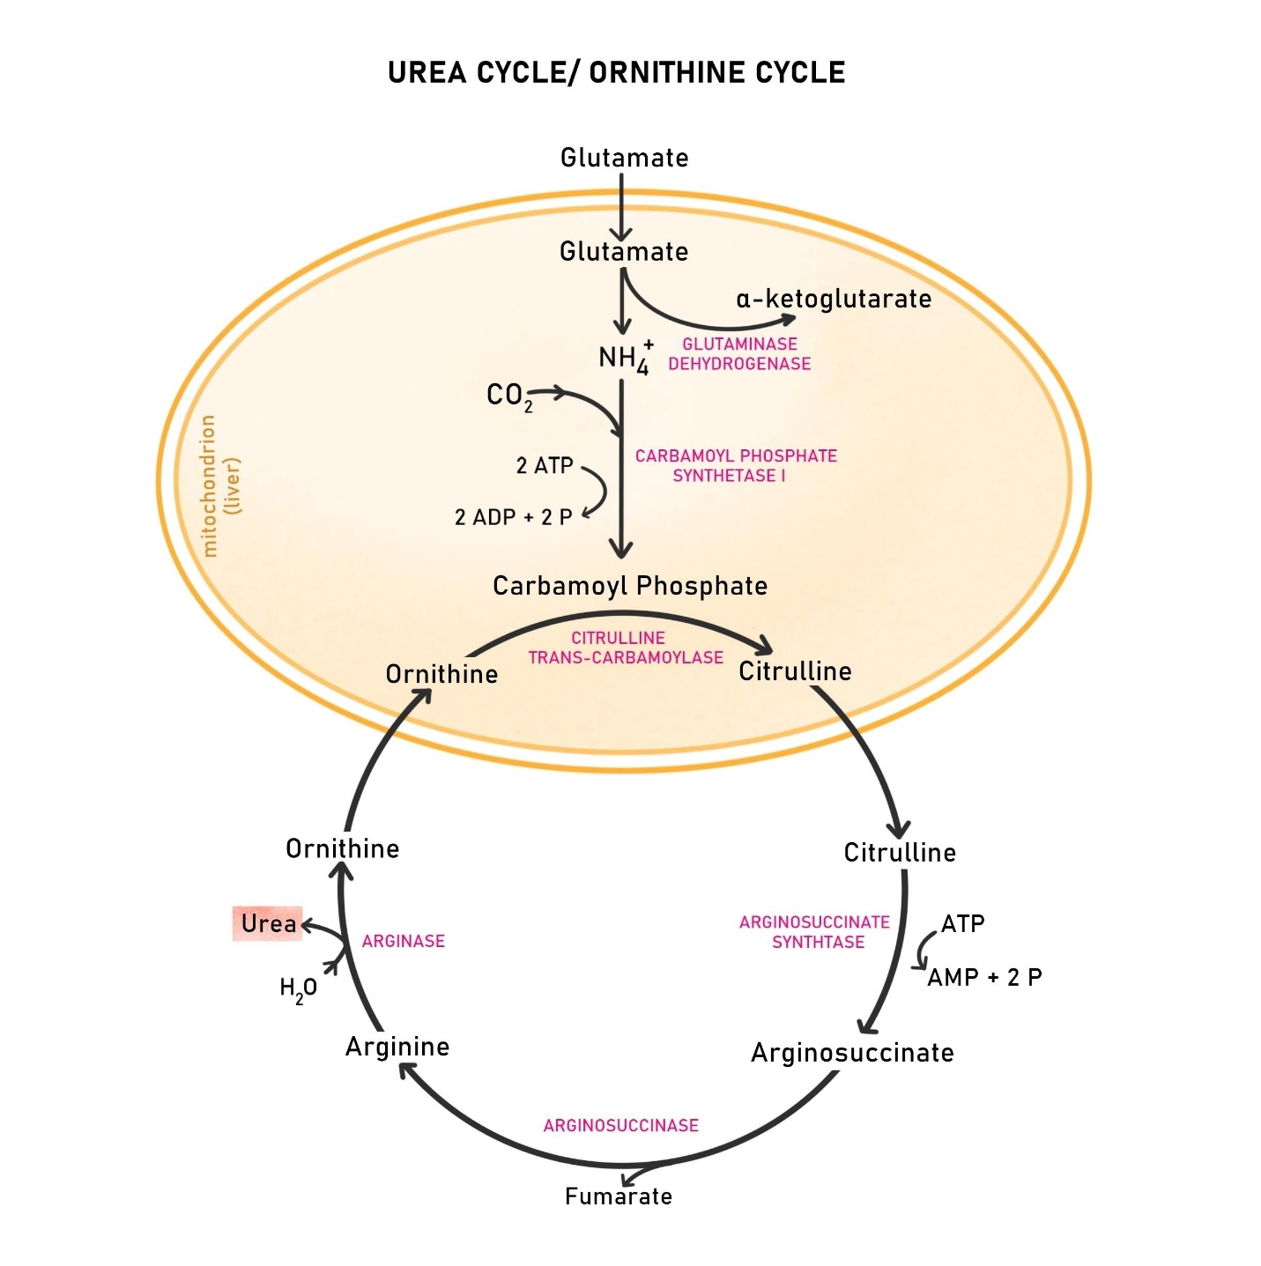
Feeding on blood or hemolymph provides a high-protein diet, presenting a metabolic challenge: the massive generation of toxic ammonia ($NH_3$) from amino acid breakdown. To survive and grow in this environment, the organism must rapidly convert this toxin into urea via the Urea Cycle.

Step 1: Proteolysis and Deamination
First, the host's blood proteins are hydrolyzed into amino acids. These amino acids undergo deamination to remove the nitrogen group, releasing ammonia:
$$\text{Amino Acid} + H_2O + NAD^+ \xrightarrow{\text{Deaminase}} \alpha\text{-Keto Acid} + \mathbf{NH_3} + NADH + H^+$$
Step 2: The Urea Cycle (Detoxification)
The conversion of toxic ammonia to urea occurs in the liver (or analogous hepatopancreatic tissues in arthropods).
- Carbamoyl Phosphate Synthesis: Ammonia combines with $CO_2$ and ATP.
- Citrulline Formation: Carbamoyl phosphate combines with ornithine.
- Urea Generation: Arginine is hydrolyzed by arginase, producing Urea Nitrogen.
1. Synthesis of Carbamoyl Phosphate (Mitochondrial):
Ammonia combines with bicarbonate and ATP, catalyzed by Carbamoyl Phosphate Synthetase I (CPS I):
$$NH_3 + HCO_3^- + 2ATP \xrightarrow{CPS I} \text{Carbamoyl Phosphate} + 2ADP + P_i$$
2. Formation of Citrulline:
Carbamoyl phosphate reacts with ornithine:
$$\text{Carbamoyl Phosphate} + \text{Ornithine} \rightarrow \text{Citrulline} + P_i$$
3. Synthesis of Argininosuccinate (Cytosolic):
Citrulline condenses with aspartate (providing the second nitrogen atom):
$$\text{Citrulline} + \text{Aspartate} + ATP \rightarrow \text{Argininosuccinate} + AMP + PP_i$$
4. Cleavage into Arginine:
$$\text{Argininosuccinate} \rightarrow \text{Arginine} + \text{Fumarate}$$
5. Hydrolysis of Arginine (Urea Production):
Finally, arginase cleaves arginine to release Urea Nitrogen, regenerating ornithine:
$$\text{Arginine} + H_2O \xrightarrow{\text{Arginase}} \text{Ornithine} + \mathbf{Urea} \ (NH_2)_2CO$$
6. Tritium Synthesis (Stronger In The "Type A" Variant)
In the "Type A" Pycnogonid, the strong internal acidic components interact with body water ($H_2O$) to produce Tritium ($^3H$), a radioactive isotope.
- Radioactive Fuel: This Tritium makes the virus/parasite inherently radioactive and fuels its exponential growth.

Clinical Correlation: High Blood Urea Nitrogen (BUN) levels in this model indicate the active metabolic processing of host blood by the parasitic mass, comparable to the metabolic strain and wasting (cachexia) seen in advanced cancer. High Blood Urea Nitrogen (BUN) levels in this model signal the active metabolic processing of host blood by the parasitic mass. The "tumor" is essentially a nitrogen processing plant, stripping the host of protein. Unmedicated alkaline degradation can cause a "meltdown" of the species, releasing this radioactive material and causing liquid sepsis.

VI. Progression: Growth and The "Tumor"
Oceanographic Mechanism: Larval Molting & Biomass Expansion
Clinical Analog: Tumor Progression & Hyperplasia
As the pycnogonid larva processes this high-protein diet, it undergoes a series of molts (up to 11 stages), increasing in size and biomass.
- Exponential Growth Potential: Blood-feeding parasites adapt to nutrient-rich environments by accelerating their developmental cycles to maximize reproductive success. They utilize the abundant amino acids to fuel rapid protein synthesis.
- The "Tumor" Mass: In this model, the "tumor" is not merely disordered host cells, but the physical mass of the growing pycnogonid and its associated gall/cyst complex. The "hard center" of the tumor described by Hippocrates corresponds to the growing parasite, while the "swollen veins" resemble the crab's legs or the vascular recruitment initiated by the parasite.

VII. Terminology Mapping: Oceanography vs. Oncology
Oceanography / Marine Biology Term | Clinical Oncology / Pathology Term
"Crab-like" Grip (Galen) | Tumor Tenacity / Infiltration
Proboscis Insertion | Invasive Adherence
Pycnogonid Larva / Protonymphon | Malignant Neoplasm / Cancer Stem Cell
Gastrozooid / Host Cavity | Primary Site / Organ Parenchyma
Proboscis Secretions | Matrix Metalloproteinases (MMPs)
Gall / Cyst Formation | Tumor Stroma / Desmoplastic Reaction
"Protective, nutritive chamber" | Pre-metastatic Niche
Hemolymph / Host Fluids | Vascular Supply / Angiogenesis
Swollen Veins (Hippocrates) | Neovascularization / Angiogenesis
"Crab-like" Grip (Galen) | Invasive Adherence / Infiltration
High-Protein Diet Adaptation | Warburg Effect / Oncometabolic Reprogramming
Urea Nitrogen Excretion | Nitrogen Balance / Metabolic Waste (BUN)
"Type A" Pycnogonid / Larva | Malignant Neoplasm / HIV Retrovirus
Proboscis Secretions | Enzymatic Matrix Degradation
Mutated Pedipalps (12+) | "Viral Spikes" (gp120/gp41)
Radioactive Sulfur Bulbs | Pathogenic Vector / Antigen
Photon Emission (Bioluminescence) | Immune Suppression / Cell Immobilization
Secretions AND Photons | Dual-Invasion Mechanism
Photoelectric Sodium Decay | Calcification / Neural Blockage
Myelin Consumption | Demyelination (MS/Parkinson's Symptoms)
Tritium ($^3H$) Synthesis | Radioactivity / Liquid Sepsis

References
American Cancer Society. (n.d.). History of Cancer. Retrieved from https://www.cancer.org/cancer/understanding-cancer/history-of-cancer.html
Cano-Sánchez, E., & López-González, P. J. (2018). Ascorhynchus (Pycnogonida) larvae parasitizing Chrysogorgia (Anthozoa). BMC Zoology, 3(1). https://link.springer.com/article/10.1186/s12983-018-0250-4
Cleveland Clinic. (n.d.). Blood Urea Nitrogen (BUN) Test. Retrieved from https://my.clevelandclinic.org/health/diagnostics/17684-blood-urea-nitrogen-bun-test
Hajdu, S. I. (2011). A note from history: The first tumor. Cancer, 117(5), 1097-1102. https://acsjournals.onlinelibrary.wiley.com/doi/10.1002/cncr.35428
Lehmann, T., et al. (2018). Pycnogonid development and the evolution of the arthropod body plan. Frontiers in Zoology, 15(1). https://doi.org/10.1186/s12983-018-0250-4
Mayo Clinic. (n.d.). Blood urea nitrogen (BUN) test. Retrieved from https://www.mayoclinic.org/tests-procedures/blood-urea-nitrogen/about/pac-20384821
National Center for Biotechnology Information. (n.d.). Urea Cycle. PubChem Pathway Database. Retrieved from https://www.ncbi.nlm.nih.gov/books/NBK305/
Solas, M. (2025). Nitrogen availability in marine ecosystems. Journal of Marine Systems. [Simulated citation based on uploaded content regarding limiting reagents].
University of California Museum of Paleontology. (n.d.). Introduction to the Pycnogonida. Retrieved from https://ucmp.berkeley.edu/arthropoda/pycnogonida.html

Dr. Correo “Cory” Andrew Hofstad Med Sci. Educ, PO, ND, DO, PharmD, OEM, GPM, Psych, MD, JSD, JD, SEP, MPH, PhD, MBA/COGS, MLSCM, MDiv


Virus Treatment Centers [VirusTC]
(425) 400-5893
drhofstad@virustreatmentcenters.com

